Analysis of 16S rRNA genes to characterize microbial community structure in marine sediments from wastewater-treatment discharge fields

Stephanie D. Friedman (friedman.stephanie@epa.gov)^{a *}, Katelyn Houghton (oim2@cdc.gov)^{a ,b} Marcus W. Beck (marcusb@sccwrp.org)^{c}, Joshua A. Steele (joshuas@sccwrp.org)^{c}

* Corresponding author
ª US Environmental Protection Agency, 1 Sabine Island Drive, Gulf Breeze, FL, 32561, USA
^{b} Permanent address: Division of Parasitic Diseases and Malaria, Center for Global Health, Centers for Disease Control and Prevention, 1600 Clifton Rd, Atlanta, GA, 30329, USA
^{c} Southern California Coastal Water Research Project (SCCWRP), 3535 Harbor Boulevard, Suite 110, Costa Mesa, CA, 92626, USA.
Abstract
Some of the nation’s largest wastewater-treatment plants are in southern California. Treated sewage is discharged offshore into the Pacific Ocean through a network of outfalls, yet little is known about the potential effects on microbial communities in the sediment. 16S rRNA genes were sequenced from sediment samples to explore the use of these data to evaluate community structure along sewage outfall gradients (close to far) and between outfall sources. Community composition was more similar across locations as distance increased from the outfall pipe, whereas communities closer to outfall pipes had high diversity and low similarity between locations. Firmicutes was the predominant bacteria phylum at most of the stations, whereas Proteobacteria and Actinobacteria dominated the site closest to the Orange County outflow. Overall, this analysis demonstrates how next generation sequencing can be used to evaluate wastewater effects on microbial communities in marine sediments.
Keywords: 16S rRNA gene sequencing; Microbial communities; Wastewater treatment; Marine sediments; Southern California
1. Introduction
Marine and estuarine microbes are critical to the natural environment and robust methods are needed to assess community changes in response to anthropogenic pressures. Bacteria and archaea play a major role in biogeochemical transformation and nutrient cycling processes that are necessary to sustain the health of freshwaters, estuaries, and oceanic ecosystems. In the Los Angeles metropolitan area (California, USA), treated sewage is discharged approximately 8-11 km offshore into the Pacific Ocean through a network of outfalls. These outfalls originate from wastewater-treatment plants that serve as many as 20 million people, presenting a novel opportunity to evaluate community response to effluent exposure. Little is known about the influence of wastewater effluent on microbial communities harbored within the sediment of effluent outfall. Not only are bacteria and viruses potentially discharged in treated effluent, but nutrients, sand, grit and organic materials can occur in watershed runoff, having potential effects on the physical and biochemical processes that occur within marine sediments (Wakelin et al., 2008).
Genetic approaches may be used to evaluate the potential effects of effluent exposure on microbial community structure on marine sediments. Sequencing the 16S rRNA gene is a rapid and feasible approach to characterize microbial communities (Sogin et al., 2006). The highly conserved 16S rRNA gene in bacteria and archaea has sufficient variability to distinguish the taxonomic composition to the individual species or Operational Taxonomic Units (OTUs) levels. The OTU is a means to characterize the 16S rRNA gene sequence based on sequence similarity (Stackebrandt and Goebel, 1994). To evaluate the potential effects of wastewater effluent on the microbial community structure, DNA was extracted and sequenced from sediment collected along the outfall gradient from the following four municipalities; Los Angeles County (Joint Water Pollution Control Plant), City of Los Angeles (Hyperion Plant), City of San Diego and Orange County. The research objective was to survey microbial communities and to identify key microbial taxa or shifts in the taxa that attributed to community variation and/or community uniqueness among and within the wastewater- treatment discharge fields. Changes in community structure related to distance from the wastewater-treatment outflows also were evaluated. This information will contribute to a baseline assessment of microbial community responses in sediment associated with wastewater- effluent discharge using a molecular approach.
2. Materials and methods
2.1 Study area and sediment collection
As part of an on-going monitoring program coordinated by the Southern California Coastal Water Research Project (SCCWRP, http://www.sccwrp.org/ResearchAreas/RegionalMonitoring.aspx), 14 sediment samples were collected along outfall pipe gradients from four southern California wastewater-treatment discharge fields as follows: 1) Los Angeles County, 2) City of Los Angeles, 3) San Diego, and 4) Orange County (Fig 1; Table 1). At each station sediment cores were taken using a Van Veen grab. Core tubes were used to extract 5 cm of sediment from the grab. Samples were placed into a 1-quart bag in a cooler with dry ice and transferred to a – 80 º C freezer until processed.
2.2 DNA extraction, PCR and sequencing
DNA was extracted from each sediment sample using a PowerSoil® DNA Isolation kit (Mo Bio Laboratories, Carlsbad, CA) and subsequently cleaned with a DNA Clean and Concentrator kit (Zymo Research, Irvine, CA). All DNA samples were sent to Argonne National Laboratory for Mi-Seq (Illumina, San Diego, CA) paired-end 250 bp sequencing of the 16S rRNA gene. The selected primers targeted the V4 region of the 16S rRNA gene to detect both Bacteria and Archaea (Caporaso et al.,2012; Apprill et al., 2015; Fouhy et al., 2016). To minimize amplification and sequencing bias, primers were modified and barcoded for Illumina Mi-Seq platform as follows. The forward primer 515fB was constructed by 1) 5’ Illumina adapter, 2) GoLay barcode 3) forward primer pad, 4) forward primer linker and 5) forward primer (515fB) with the following sequence:

5’ AATGATACGGCGACCACCGAGATCTACACGCT XXXXXXXXXXXX TATGGTAATT GT GTGYCAGCMGCCGCGGTAA 3’

The reverse primer 806rB was modified by i) reverse compliment of 3’ Illumina adapter, ii) reverse primer pad iii) reverse primer linker and iv) reverse primer (806rB) resulting in the following sequence:

5’ CAAGCAGAAGACGGCATACGAGAT AGTCAGTCAG CC GGACTACNVGGGTWTCTAAT 3’

2.3 DNA sequence analysis
The resulting 16S rRNA sequences were processed using mothur version 1.39.5 (Schloss et al., 2009) following the mothur MiSeq protocol (accessed 6/12/17). Contiguous DNA sequence segments (contigs) were assembled using the forward and reverse sequences. Sequences were aligned to and classified with the Silva database v128 (Quast et al., 2013) and any sequences not aligning to the desired region were screened and removed. Any sequences classified as Chloroplast, Mitochondria, unknown, or Eukaryota also were removed. Chimeras were removed using UCHIME (Edgar et al., 2011) (http;//drive5.com/uchime). Sequences were clustered into OTUs based on 97% nucleotide sequence identity. Each sample was sub-sampled to normalize the data and account for differences in sampling effort between samples. Error rates for each sequence run were assessed using the BEI Mock Community B BEI HM-277D. This reagent was obtained through BEI Resources, NIAID, NIH as part of the Human Microbiome Project (Genomic DNA from Microbial Mock Community B (Staggered, High Concentration), v5.2H, for Whole Genome Shotgun Sequencing; BEI Resources, Manassas, VA).
2.4 Statistical analyses
2.4.1. Multivariate analysis
The statistical analyses were conducted to evaluate community differences related to location (each of four wastewater outfalls) and distance from the outfall pipe at each location. The abundance and taxonomy data at the OTU level were analyzed using the multivariate statistics package, Primer v7 (Primer-E, UK). Data were log transformed (log[x+1]) to down weight the contributions of the most dominant taxa and Bray-Curtis similarity values were calculated from the transformed data (Bray and Curtis, 1957). OTU level non-metric multidimensional scaling was based on the Bray-Curtis dissimilarity matrix of abundance data. SIMPER analysis (similarity percentages) was used on the OTU level data to determine species contributions to within-group similarity. SIMPER calculates the contribution of each OTU to the Bray-Curtis similarity of a specified group.
2.4.2. Analysis of diversity
Alpha diversity (Fisher et al., 1943) was estimated at the genus level for each sampling station per site. Differences in diversity between sites were evaluated using a simple analysis of variance (ANOVA) to test for a main effect of distance from the wastewater outflow pipes or by municipality. Diversity estimates were grouped by distance categories across municipalities for the first analysis. Similarly, diversity estimates were grouped by municipality across the distance categories for the second analysis. Assumptions for ANOVA were verified using Bartlett’s test of equal variances between groups with the diversity data and Shapiro-Wilk test of normality of the residuals from the model output (R Core Team, 2017).
3. Results
3.1 Microbial communities
3.1.1. 16S rRNA gene analysis
A total of 14 sediment samples were collected. The sequenced DNA from the samples resulted in 1,095,155 contigs assembled using the forward and reserve reads, with an average sequence length of 254 bp. OTUs based on 97% nucleotide sequence identity resulted in a total of 564,711 sequences. Each sample was sub-sampled to 27,499 sequences per sample. The sequencing error rate was determined as 0.00013971 (0.01%) using the BEI Mock Community.
3.1.2. Abundant taxa
Firmicutes was the dominant bacteria phylum (39.4-70%) across all municipalities and distance categories from the outfall pipes (Supplement 1). An exception was observed at the Orange County “close” location that was dominated by the phyla Proteobacteria (34.6%), Planctomycetes (12%), Actinobacteria, (11.9%), Bacteroidetes (11.6%), Chloroflexi (8.6%) and Firmicutes (7%). Proteobacteria was the second most abundant phylum ranging from 34.6% (ORCO_{c}) to 14% (LACI_{f}) across all stations. Planctomycetes was the third most abundant phylum ranging from 3-8%, in all municipalities/stations except for ORCO_{c} (12%). Bacteroidetes ranged from 2-4% in all stations/municipalities except for ORCO_{c (}11.6%) (Fig 2; Supplement 1).
For genera, Peptostreptoccocaecea_unclassified_ genus (phylum Firmicutes) was often the most abundant genus ranging from 29-2.6% across all stations except ORCO_{c} (0.18%), followed by Bacillaceae_unclassified_genus (25-4%), except for ORCOc (2.89%). All genera in ORCO_{c} were generally not abundant compared to the other stations, with the most abundant being OM1_clade_ge (7.7%), Pir4_lineage (5.8%), Desulfobulbaceae_uncultured (4.2%) and the remaining approximately top 20 abundant genera being around 2% or le_genus ss. OM1_clade_ge was 7.7 and 3.6%, respectively, at the two ORCO stations (close and intermediate1) and was approximately 2% or less at the remaining 12 stations. Overall, Peptostreptococcaecea_ unclassified_ genus was the dominant genus at three stations (29-16%), Bacillaceae_unclassified_ genus was dominant at four stations (25-13%), and Clostrididiaceae_1 _uncultured_ genus (17-4%) was abundant at 10 stations. Tepidibacter was abundant (21-4.7%) at 10 out of the 14 stations (Supplement 2).
3.2 Statistical analyses
3.2.1. Multivariate analysis
A non-metric multidimensional scaling plot (nMDS) based on the Bray-Curtis dissimilarity matrix of abundance at the OTU level was illustrated in Figure 3. Samples were keyed based on municipality with lines joining the distance categories from the outfall pipe. These results demonstrated that samples farthest from the pipe were more similar in community structure between municipalities (site groupings toward the center of the plot), whereas samples closer to the pipe were more different (more separation, removed from the plot origin). The response was somewhat variable depending upon the wastewater municipality, however, the overall trend was the same.
SIMPER analysis showed that communities within groups “close” to the pipe were least similar, while the “farthest” samples from the outfall were most similar (Table 2). These similarity measures reflect the same trends observed in Figure 3.
3.2.2. Analysis of diversity
Diversity was highest closest to the outfall pipes and declined with increasing distance independent of municipality (Table 3, F = 8.6, df = 2, 11, p < 0.01). Post-hoc comparisons suggested that the “far” stations were significantly different from the “intermediate” and “close” stations (p<0.01; Table 3). Over half (adjusted R² of 54%) of the variation in diversity was explained by distance from the outfall pipes. These tests support the multivariate findings that microbial communities farthest from the outfall pipes were different than the sample stations closest to the pipes. Diversity at each station was not significantly different between municipalities independent of distance from the outfall pipes.

4. Discussion
Results suggest that wastewater effluent can alter microbial communities in marine sediments by increasing diversity near outfalls, although these communities may differ depending on the effluent source. Community structure may converge toward a “baseline” natural condition as effects of effluent are diminished with increasing distance from outfalls. Neither the physical location along the southern California coast (i.e., municipality) nor the depth of the sediment samples (56m-98m) were strongly associated with microbial community composition. Proximity to the outfall pipe was the dominant factor associated with community structure, as samples converged in similarity as distance from the outfalls increased (Fig 3). Some exceptions to the general patterns were observed. The microbial community in the Orange County “close” to the outfall pipe was most unique relative to the other stations. Although the nMDS plot demonstrated a trend in the shift in the microbial community at the OTU level, it appears that the samples closest to the pipes were affected by geochemical changes independent of spatial variation.
These results provide novel information on the effects of treated wastewater effluent on microbial communities that inhabit marine sediments and generally support other studies that have demonstrated similar responses in different environments or anthropogenic pressures. An increase in microbial community diversity was experimentally demonstrated in organic-enriched sediment cores suggesting a recruitment or co-mixing of different microbes to the enriched sediments (Garland et al., 2016). Saarenheimo et al., (2017) evaluated the microbial community in two sites from Boreal Lake sediments, reporting a significant shift in communities between the discharge (outfall) site and the control station. In addition, they noted a gradual shift towards the normal community located downstream from the outfall. In other studies, microbial community changes have been observed in response to land-based influences such as paper mills (Guo et al., 2016), wastewater outfall along coral reefs (Staley et al., 2017), wastewater effluent discharge in Australian stream sediments (Wakelin et al., 2008) and along a nitrogen pollution gradient (Xiong et al., 2014).
Overall, the most abundant bacteria were phyla Firmicutes followed by phyla Proteobacteria. When examining the top abundant bacteria, phyla Firmicutes was dominant across all municipalities and distance-from-the-pipe, except for Orange County (Fig 2). In contrast, the most abundant phyla at the Orange County “close” station were Proteobacteria, Actinobacteria, Planctomycetes, Bacteroidetes and Chloroflexi. For reasons unknown, this community was altered resulting in shifts and a declined percent abundance at that station, however the “close” stations at the remaining three wastewater-treatment plants did not appear to be as affected. The data were normalized and therefore the sequence reads would not have influenced the data outcome. Noteworthy is that at all stations the most abundant Firmicutes (39-70%) was, in contrast, at very low abundance (7%) at ORCOc suggesting the outfall contributed factors that limited productivity and reproducibility of the members of the Firmicutes phyla at that location.
Chu et al (2018) reported Proteobacteria and Bacteroidetes as the most abundant phyla in effluents and sediments collected from the wastewater-treatment plant outfall in Lake Michigan and the abundance of these two phyla decreased in sediment samples with increasing distance from the treatment plants. Proteobacteria were found to be the dominant phylum at wastewater-treatment outfalls in China (Liu et al., 2016; Zhang et al., 2016; Zhang et al., 2014), Canada, USA and Singapore (Zhang et al., 2012). Bacteroidetes was high in abundance at outfall stations in southeast Florida (Campbell et al., 2015) and was the second most abundant phylum in activated sludge from eight wastewater-treatment plants in China (Liu it al., 2016). Fecal-polluted sites were dominated by Proteobacteria, Firmicutes, Actinobacteria, Bacteroidetes and Spirochaetes in an urban Santa Ana River watershed in southern California (Ibekwe et al., 2016) with Proteobacteria being the dominant phylum. Vierheilig et al., 2015, noted that fecal communities collected from a broad range of animals were dominated by Firmicutes, Bacteroidetes and Proteobacteria.
Reportedly, Actinobacteria are widely distributed in marine habitats (Stach et al, 2003), however this phylum was most abundant (11.9%) at the closest outflow station for the Orange County treatment plant when compared to the other treatment-plant stations (1.7-5.8%). Chen et al (2016) noted the Actinobacteria were significantly correlated to pH, total organic carbon and other geochemical factors rather than to spatial distributions in deep-sea sediments from the Southwest Indian Ridge. These findings may corroborate and support the evidence of the Actinobacteria being the fourth to fifth most abundant phyla at the wastewater outfall stations in this study.
The phyla Firmicutes and Bacteroidetes comprise >98% of the 16S rRNA gene sequences isolated from the intestinal flora of mammals (Thomas et al., 2011; Ley et al., 2006). The gastrointestinal tract of humans and animals contains Bacteroidetes (Campbell et al., 2015; Qin et al., 2010) and this phylum have been known to occur in a variety of habitats such as soils, oceans and freshwaters (Thomas et al., 2011). Within the phylum Bacteroidetes is the genus Bacteroides, which has been reported as the most abundant fecal bacteria (Moore and Holdeman, 1974; Sghir et al., 2000). Therefore, it is not surprising that Bacteroidetes was most abundant at ORCO_{c} (11.6%) compared to the remaining sample stations (1.5-4%). At ORCO_{c}, ORCO_{i1} and LACO_{i2} the genus Bacteroides ranged from 2-7% but was negligible (<1%) at the remaining stations. Liu et al., 2016, reported phylum Bacteroidetes as the second most abundant phylum from eight wastewater-treatment plants with activated sludge. Therefore, the prevalence of the phyla Firmicutes and Bacteroidetes abundance in wastewater-treatment effluents supports these results at the California wastewater treatment outfall stations. However, community structure may converge toward a “baseline” natural condition as effects of effluent are diminished with increasing distance from the outfall pipes.
5. Conclusion
The genetic approach used in this study is useful in demonstrating a shift in affected sediment communities associated with anthropogenic stressors. Specifically, this study demonstrates the application of next-generation sequencing technology to understand the effects of wastewater effluents on microbial community structure in marine sediments from southern California. Microbial community diversity increased near the wastewater-treatment outflow pipe whereas the microbial communities were most similar with increasing distance from the outflow pipes. These observations suggest that resident microbial community resilience occurs along the outfall gradient. Understanding the drivers of microbial community resiliency may help inform improved wastewater-treatment options that minimize environmental impacts.

Supplemental Material
Supplement 1: Percent abundance Phyla
Supplement 2: Percent abundance Genera

Disclosures
There are no conflicts of interest. All authors have approved the final article.

Acknowledgments
Dr. Erik Pilgrim, US EPA, for the sediment samples; Dr David Gillett, Southern California Coastal Water Research Project (SSCWRP), for municipality information, Elizabeth (Annie) Paulukonis for GIS analysis; and Emilie Cooper for editorial review. The views expressed in this article are those of the authors and do not necessarily reflect the views or policies of the U.S. Environmental Protection Agency. Any mention of trade names, products, or services does not imply an endorsement by the U.S. Government or the U.S. Environmental Protection Agency (EPA). The EPA does not endorse any commercial products, services, or enterprises.

References
Apprill, A., McNally, S., Parsons, R., Weber, L., 2015. Minor revision to V4 region of SSU rRNA 806R gene primer greatly increases detection of SAR11 bacterioplankton. Aquat. Microb. Ecol. 75:129-137. doi: 10.3354/ame01753
Bray, J. R., Curtis, J.T., 1957. An ordination of upland forest communities of southern Wisconsin. Ecol. Monogr. 27:325-349. https://doi.org/10.2307/1942268
Campbell, A.M., Fleisher, J., Dinigalliano, C., White, J.R., Lopez, J.V., 2015. Dynamics of marine bacterial community diversity of the coastal waters of the reefs, inlets, and wastewater outfalls of southeast Florida. Microbiol. Open. 4(3):390-408. https://doi.org/10.1002/mbo3.245
Caporaso, J.G., Lauber, C.L., Walters, W.A., Berg-Lyons, D., Huntley, J., Fierer, N., Owens, S.M., Betley, J., Fraser, L., Bauer, M., Gormley, N., Gilbert, J.A., Smith, G., Knight, R., 2012. Ultra-high-throughput microbial community analysis on the Illumina HiSeq and MiSeq platforms. ISME J. 6:1621-1624. doi: 10.1038/ismej.2012.8.
Chen, P., Zhang, L., Guo, X., Dai, X., Liu, L., Zi, L., Wang, J., Song, L., Wang, Y., Zhu, Y., Huang, L., Huang, Y., 2016. Diversity, Biogeography, and Biodegradation Potential of Actinobacteria in the Deep-Sea Sediments along the Southwest Indian Ridge. Front. Microbiol. 29(7):1340. doi: 10.3389/fmicb.2016.01340.
Chu, B.T.T., Petrovich, M.L., Chaudhary, A., Wright, D., Murphy, B., Wells, G., Poretsky, R., 2018. Metagenomics reveals the impact of wastewater treatment plants on the dispersal of microorganisms and genes in aquatic sediments. Appl. Environ. Microbiol. 84(5):e02168-17.
Edgar, R.C., Haas, B.J., Clemente, J.C., Quince, C., Knight, R., 2011. UCHIME improves sensitivity and speed of chimera detection. Bioinformatics. 27(16):2194–2000. doi: 10.1093/bioinformatics/btr381.
Fisher, R.A., Corbet, A.S., Williams, C.B., 1943. The relation between the number of species and the number of individuals in a random sample of an animal population. J. Anim. Ecol. 12, 42–58. doi: 2307/1411.
Fouhy, F., Clooney, A.G., Stanton, C., Claesson, M.J., Cotter, P.D., 2016. 16S rRNA gene sequencing of mock microbial populations- impact of DNA extraction method, primer choice and sequencing platform. BMC Microbiol. 16:123-135. https://doi.org/10.1186/s12866-016-0738-z
Garland, P.E., Lucas, S., Fagervold, S.K., Peru, E., Pruski, A.M., Vétion, G., Dupuy, C., Guidien, K., 2016. Disturbance increases microbial community diversity and production in marine sediments. Front. Microbiol. 7:1950. doi: 10.3389/fmicb.2016.01950
Guo, J., Zhao, L., Lu, W., Jia, H., Sun, Y., 2016. Bacterial communities in water and sediment shaped by paper mill pollution and indicated bacterial taxa in sediment in Daling River. Ecol. Indic. 60:766-773. https://doi.org/10.1016/j.ecolind.2015.08.028
Ibekwe, A.M., Ma, J., Murinda, S.E., 2016. Bacterial community composition and structure in an urban river impacted by different pollution sources. Sci. Total Environ. (566-567):1176-1185. https://doi.org/10.1016/j.scitotenv.2016.05.168
Ley, R.E., Turnbaugh, P.J., Klein, S., Gordon, J.I., 2006. Microbial ecology: human gut microbes associated with obesity. Nature 444, 1022–1023. doi: 10.1038/4441022a
Liu, T., Liu, S., Zheng, M., Chen, Q., Ni, J., 2016. Performance assessment of full-scale wastewater treatment plants based on seasonal variability of microbial communities via high-throughput sequencing. PloS ONE 11(4):e0152998.
doi: 10.1371/journal.pone.0152998.
Moore, W.E., Holdeman, L.V., 1974. Special problems associated with the isolation and identification of intestinal bacteria in fecal flora studies. Am. J. Clin. Nutr. 27, 1450–1455. doi: 10.1093/ajcn/27.12.1450
Qin, J., Li, R., Raes, J., Arumugam, M., Burgdorf, K.S., Manichanh, C., et al., 2010. A human gut microbial gene catalogue established by metagenomic sequencing. Nature. 464:59-65. doi:10.1038/nature08821
Quast, C., Pruesse, E., Yilmaz, P., Gerken, J., Schweer, T., Yarza, P., Peplies, J., Glöckner, F.O., 2013. The SILVA ribosomal RNA gene database project: improved data processing and web-based tool. Nucleic Acids Res. 41(D1):D590-D596. doi: 10.1093/nar/gks1219
R Core Team., 2017. R: A language and environment for statistical computing, v3.4.3. R Foundation for Statistical Computing, Vienna, Austria. URL https://www.R-project.org/
Saarenheimo, J., Aalton, S.L., Rissanen, A.J., Tiirola, M., 2017. Microbial community response on wastewater discharge in Boreal Lake sediments. Front. Microbiol. 8:750. https://doi.org/10.3389/fmicb.2017.00750
Schloss, P.D., Westcott, S.L., Ryabi, T., Hall, J.R., Hartmann, M., Hollister, E.B., Lesniewski, R.A., Oakley, B.B., Parks, D.H., Robinson, C.J., Sahl, J.W., Stres, B., Thallinger, G.G., Van Horn, D.J., Weber, C.F., 2009. Introducing mothur: Open-source, platform-independent, community-supported software for describing and comparing microbial communities. Appl. Environ. Microbiol. 75(23):7537-7541.
doi: 10.1128/AEM.01541-09
Sghir, A., Gramet, G., Suau, A., Rochet, V., Pochart, P., Dore, J., 2000. Quantification of bacterial groups within human fecal flora by oligonucleotide probe hybridization. Appl. Environ. Microbiol. 66(5):2263–2266.
doi: 10.1128/AEM.66.5.2263-2266.2000
Sogin, M.L., Morrison, H.G., Huber, J.A., Welch, D.M., Huse, S.M., Neal, R.R., Arrieta, J.M., Herndl, G.J., 2006. Microbial diversity in the deep sea and the underexplored “rare biosphere.” Pro, Natl. Acad. Sci. USA, 103(32):12115-12120.
https://doi.org/10.1073/pnas.0605127103
Stach, J.E.M., Maldonado, L.A., Ward, A.C., Goodfellow, M., Bull, A.T., 2003. New primers for the class Actinobacteria: application to marine and terrestrial environments. Environ. Microbiol. 5(10): 828–841. https://doi.org/10.1046/j.1462-2920.2003.00483.x
Stackebrandt, E., Goebel, B.M., 1994. Taxonomic note: A place for DNA-DNA reassociation and 16S rRNA sequence analysis in the present species definition in bacteriology. Int. J. Syst. Evol. Microbiol. 44(4):846-849.
doi: 10.1099/00207713-44-4-846
Staley, C., Kaiser, T., Gidley, M.L., Enochs, I.C., Jones, P.R., Goodwin, K.D., Sinigalliano, C.D., Sadowsky, M.J., Cuan, C.L., 2017. A next-generation sequencing approach to characterize the impacts of land-based sources of pollution on the microbiota of Southeast Florida coral reefs. Appl Environ. Microbiol. 83(10):8-16.
https:// doi.org/10.1128/AEM.03378-16
Thomas, F., Hehemann, J.H., Rebuffet, E., Czjzek., M., Michel, G., 2011. Environmental and gut Bacteroidetes: The food connection. Front. Microbiol. 2:Article 93. doi: 10.3389/fmicb.2011.00093
Vierheilig, J., Savio, D., Ley, R.E., Mach, R.L., Farnleitner, A.H., Reischer, G.H., 2015. Potential applications of next generation DNA sequencing of 16S rRNA gene amplicons in microbial water quality monitoring. Water Sci. Technol. 72(11):1962-1972. doi: 10.2166/wst.2015.407.
Wakelin. S.A., Colloff, M.J., Kookana, R.S., 2008. Effect of wastewater treatment plant effluent on microbial function and community structure in the sediment of a freshwater stream with variable seasonal flow. Appl. Environ. Microbiol. 74(9):2659-2668. doi: 10.1128/AEM.02348-07
Xiong., J. Xianse, Y., Wang, K., Chen, H., Hu, C., Zhu, J., Zhanga, D., 2014. Biogeography of the sediment bacterial community responds to a nitrogen pollution gradient in the East China Sea. Appl. Environ. Microbiol. 80(6):1919-1925.
doi:10.1128/AEM.03731-13
Zhang,Y., Chen, L., Sun, R., Dai, T., Tian,J., Liu, R., Wen, D., 2014. Effect of wastewater disposal on the bacterial and archaeal community of sea sediment in an industrial area in China. FEMS Microbiol. Ecol. 88:320-332. https://doi.org/10.1111/1574-6941.12298
Zhang,Y., Chen, L., Sun, R., Dai,T., Tian , J., Zheng ,W., Wen, D., 2016. Temporal and spatial changes of microbial community in an industrial effluent receiving area in Hangzhou Bay. J. Environ. Sci. (China) 44:57-68. doi: 10.1016/j.jes.2015.11.023.
Zhang, T., Shao, M.F., Ye, L., 2012. 454 Pyrosequencing reveals bacterial diversity of activated sludge from 14 sewage treatment plants. ISME J. 6(6):1137-1147.
doi: 10.1038/ismej.2011.188

Figures
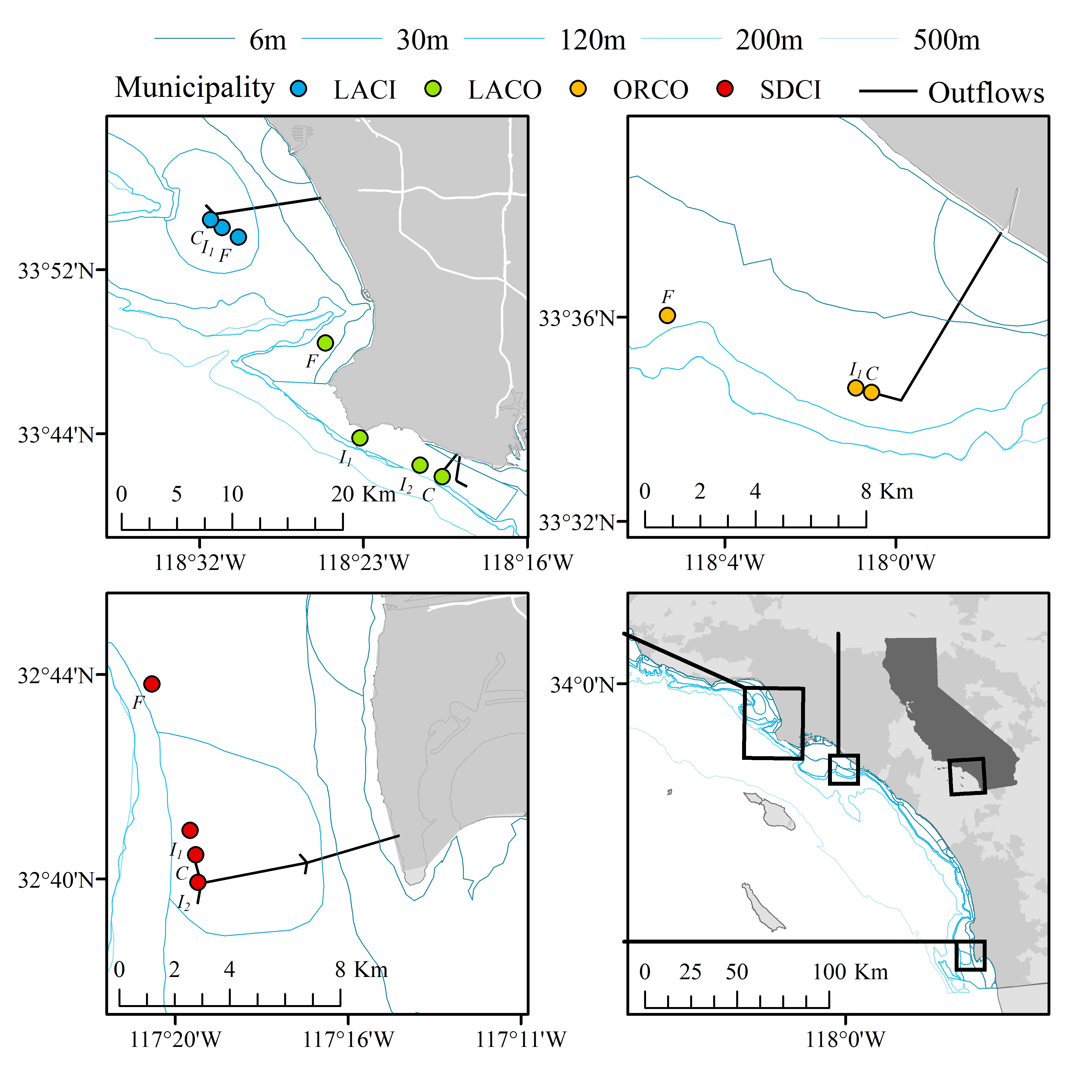
Fig 1. Sediment sampling stations from the wastewater-treatment discharge fields along the southern California coast. Stations are diagramed by their respective municipality. See Table 1 for a description of each station. Text designations at each site indicate relative categories for distance from each outflow pipe (C = close, I₁, I₂ = intermediate, F = far). LACI is City of Los Angeles; SDCI is City of San Diego, LACO is Los Angeles County and ORCO is Orange County, California.

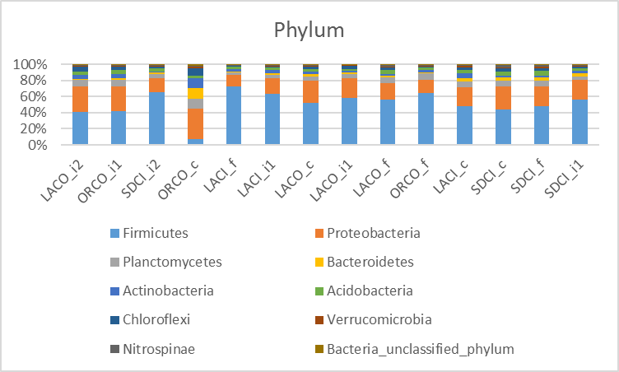
Fig 2. Top ten phyla based on wastewater-treatment plant (municipality) and distance from the outfall pipe as determined by percent abundance. (C = close, I₁, I₂ = intermediate, F = far). LACI is City of Los Angeles; SDCI is City of San Diego, LACO is Los Angeles County and ORCO is Orange County, California.

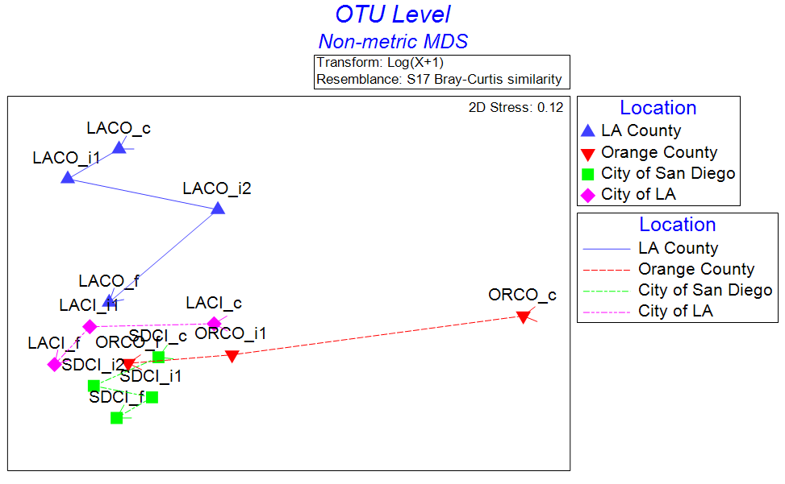
Fig 3. OTU level non-metric multidimensional scaling plot of the Bray-Curtis similarity values from abundance data (Primer v7). Abundance data were log(X+1) transformed prior to analysis. Samples were plotted based on municipality with a trajectory based on distance from the outfall pipes. Colors indicate municipality and subscripts indicate distance categories from an outflow pipe at each site (“F” is far, “C” is close, “I” is intermediate). LACI is City of Los Angeles; SDCI is City of San Diego, LACO is Los Angeles County and ORCO is Orange County, California.
Tables

Table 1. Site locations for sediment collection. Each station was grouped by nearest governing municipality and further grouped by relative location from the outflow pipe of the nearest wastewater-treatment plant (WWTP).
WWTP | Abbreviation | Depth (m) | Distance from  outfall pipe (m) | Lat, Lon | Accession number
City of Los Angeles | LACI_{c} | 59 | close (0) | 33.91; -118.52 | SAMN09909633
 | LACI_{i1} | 57 | intermediate₁ (1257) | 33.90; -118.52 | SAMN09909628
 | LACI_{f} | 56 | far (2919) | 33.89; -118.50 | SAMN09909627
City of San Diego | SDCI_{c} | 98 | close (0) | 32.67; -17.33 | SAMN09909634
 | SDCI_{i1} | 98 | intermediate₁ (1106) | 32.67; -17.32 | SAMN09909636
 | SDCI_{i2} | 98 | intermediate₂ (1005) | 32.68; -17.33 | SAMN09909625
 | SDCI_{f} | 98 | far (7048) | 32.73; -117.34 | SAMN09909635
Orange County | ORCO_{c} | 59 | Close (0) | 33.58; -118.02 | SAMN09909626
 | ORCO_{i1} | 56 | intermediate₁ (656) | 33.58; -118.01 | SAMN09909624
 | ORCO_{f} | 56 | far (8083) | 33.60; -118.09 | SAMN09909632
Los Angeles County | LACO_{c} | 61 | close (0) | 33.70; -118.34 | SAMN09909629
 | LACO_{i1} | 61 | intermediate₁ (2176) | 33.71; -118.35 | SAMN09909630
 | LACO_{i2} | 61 | intermediate₂ (7907) | 33.73; -118.40 | SAMN09909623
 | LACO_{f} | 61 | far (16565) | 33.81; -118.43 | SAMN09909631

Table 2. Similarity of each “distance from the outfall pipe” group as determined by the SIMPER statistical analyses.
Group Average Similarity Within Group
Close 40.87
Intermediate 44.71
Far 48.98

Table 3. Summary of analysis of variance results for community diversity with distance from outfall pipe. Diversity measures were based on Fisher’s Alpha (Fisher et al., 1943) using abundance of genera at each site. The model intercept is the average diversity estimate (standard error in parentheses) at all close sites and the remaining parameter estimates (intermediate and farthest) are referenced accordingly.

 | Microbial Community
 | Models
Constant (close) | 88.68∗∗∗
 | (3.88)
Intermediate | −14.72∗∗
 | (5.01)
Farthest | −22.30∗∗∗
 | (5.48)
Observations | 14
R² | 0.61
Adjusted R² | 0.54
Residual Std. Error (df = 11) | 7.75
F Statistic (df = 2; 11) | 8.63∗∗∗
Note: ∗∗p<0.05; ∗∗∗p<0.01

